Template of Hardware Metapaper
For submission to the Journal of Open Hardware
To complete this template, please replace the blue text with your own. The paper has five main sections: (1) Overview; (2) Quality Control; (3) Application (4) Build Details (5) Discussion (6) Licenses.

Please adhere strictly to this exact format (including indentation, justification, and fonts)

(1) Overview

Title
A Real Time Embedded Sound Localization Platform for Integrating Directionality into Sound Wave Signatures

Authors
Chikkala Aneesh Arnav

Independent

Abstract
Real-time sound localization through embedded hardware has remained a technical challenge due to constraints in power and compute resource allocation. This paper presents an efficient method for real time sound localization at 10µS per computation. built on a custom microphone array, Filtering and Weighing algorithms pre-process the sound. The system then uses a PID based error correction algorithm assisted with an Embedded Decision Validation Network to localise the sound source. It then integrates a directional vector into the original sound wave's signature, enabling the addition of directional context to recorded and processed sound waves.

Metadata Overview
Main design files: https://github.com/aneesharnavch/Embedded-Sound-Localisation-/tree/main
Target group: Researchers interested In Embedded Sound localization and other related disciplines
Skills required: PCB Manufacturing - intermediate; surface mount PCB assembly- advanced; Data Analysis – intermediate; Electronics and programming – intermediate.
Replication: No External Builds known to the author but multiple internal prototypes documented.
See section “Build Details” for more detail.

Keywords
embedded sound localization; directional audio; microphone arrays; assistive hearing; real-time signal processing.

Introduction
Accurate Sound localization in embedded systems is difficult due to several factors including real-time latency constraints, Hardware limitations, Power limitations, limited computational resource allocation and unpredictable acoustic environments [1]. The presented Hardware system offers a compact real time sound localization device that leverages microphone array input, embedded signal processing, and directionally-aware sound reconstruction [2].

Unlike Conventional systems that rely on brute force approximations or bulky, power intensive methods, this platform uses well constrained-inference models to better approximate and embed directional vectors directly into the acoustic signature. It’s applications particularly hold promise in the Assistive hearing technologies where lightweight directional awareness modules can enhance sound perception for those with certain auditory impairments.

Designed using off-the-shelf microcontrollers and custom PCB with integrated microphone arrays with the system is fully reproducible and is suitable for Embedded AI deployment. By enabling real-time directionally-aware sound source localization on resource-constrained embedded platforms allowing varied use in both consumer and research grade applications.

Overall Implementation and design

Hardware Implementation and design:
The hardware was implemented around the ESP32-S3 module used for its dual-core Audio processing capabilities. The main unit comprises of a custom designed PCB with the ESP32-S3, Custom LM356DR based microphone array, materials include FR4 for the PCB substrate and standard SMT electronic components for passive and active elements for electrical connections. Architecture is meant to be modular, with clear electrical separation with excess pins left out for further integration for application specific purposes.

Assembled hardware highlights clearly labelled test points for modular troubleshooting, assembly does not require specialist equipment beyond basic SMD soldering skills and standard lab measurement tools, the design however is made with scalability in mind. Reducing footprint sizes offers drastic size reduction physically. Variations include increased application specific microphone and amplifier variations to optimize for cost, form factor or availability resources.

Software Implementation and design:
The software components, utilizes the default ESP32-S3 ESPRESSIF firmware, running a hedging algorithm handling by data supported by the MicroDSP library under FreeRTOS. “Hedging” was chosen in favour of a TensorFlow mini-AI trained model due to its computational load as highlighted in Table 1.

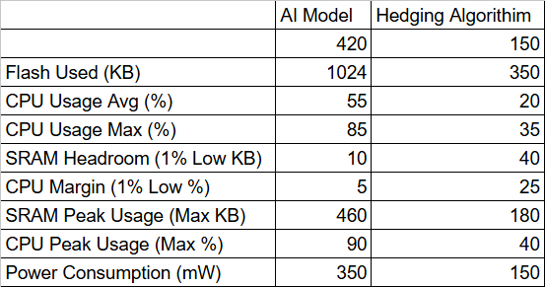
Table 1: Resource Table comparing resources between algorithms

(2) Quality control

Calibration

Resultant accuracy quantification:
To verify the reliability of each individual microphones reading, extensive data was collected via each microphone through a controlled signal generating speaker across varying distances through varying frequency ranges, going from 15-300cm in distance to 1-20kHz for the frequency. Through data on amplitude variance across time, parameters for the Kaiser Windowed Filtering Algorithm were computed [4]. For instance, Figure 1 shows the microphones Analog response to a 4kHz Sine Wave from 15cm apart.

Calibration is further refined by comparing proportions between collected and ideal data using a curve fitting approach in a MATLAB model to compensate for frequency dependent deviation allowing the verification of signal integrity before further calibrating for dependent variables used in the Kaiser windowed FIR Filter.
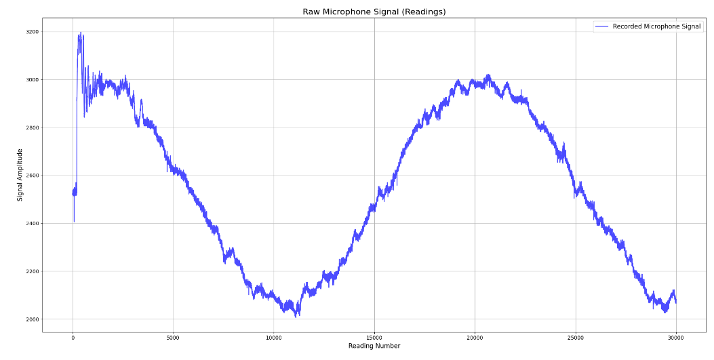
Figure 1: Raw Microphone Signal over Time for a 4kHz wave from 15cm apart

Coefficient Estimation from Extensive Data
The collected data was used along with the Curve fitting toolbox on MATLAB, parameters based on Variance of expected to resultant signals was used to exclude outliers in the Kaiser Windowed filter used.
The kaiser windowed FIR filter is typically defined as:

$k[m]= \frac{\sin{(πf_{c}(m-α))}}{π(2f_{c}(m-α))}w[m] , m=0,1,.........,M$

such that; $m$ represents the sample index from 0 to M, M is the filter order, $f_{c}$ represents the normalised cutoff and $α$ is the midpoint of the index of the window. $w[m]$is the kaiser window function defined as:
$$w[m] = \frac{ I_{0}(β\sqrt{1-{\frac{(m-α)}{α^{2}}}^{2}})}{I_{0}(β)}$$

in which $I_{0}$(x) represents the zeroth-order Bessel function [3].

Using the afore mentioned data with the curve fitting on MATLAB allowed estimations on many of the constants in these expressions, allowing for easier calibration. Their Approximations in this design are:

$$f_{c}≈ 0.25$$
β $≈$8.6
M ≈ 43.479
$α$ ≈ 21.741

Cross comparison and window homogeneity
To ensure calibration before each iteration, raw and filtered data is compared to assess polarity reversals while considering variance in base microphone values to address dipropionate distortion with respect to frequency due to hardware frequency response limitations.
The parameters for the cross comparison are evaluated based on the gradient of the scalar field accounting for frequency response, expected frequency response and distance from origin. Better visualised as the derivative of variance with respect to frequency and distance. Figure 2 shows this visualised with the response of the microphone to square waves.

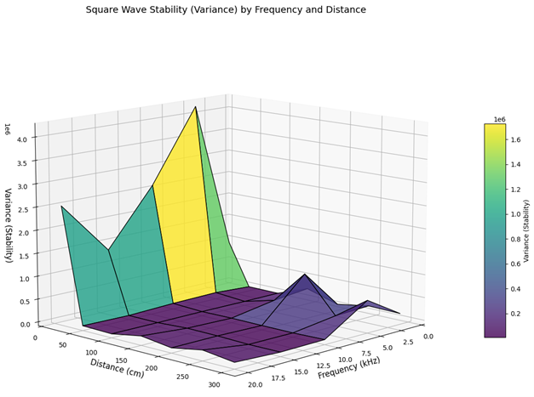
Figure 2: Frequency and Distance Dependent Variance of Microphone Response to Square Waves

Localization parameters
Once a fully calibrated microphone has been attained for the user’s intended application, Localization parameters such as resource allocation, error coefficient and output medium can be modified via software and be cross referenced to a database of expected input/output values to ensure accuracy within the defined application specific boundaries.

General testing
For testing to ensure proper calibration is verifying resistances and capacitances match their expected values to ensure no PCB faults or poor soldering joints to cause any electrical circuit failures followed by a premilitary microphone test, feeding sine waves from an audio speaker or a signal generator and monitoring the analog output for expected responses. Additionally, it is highly recommended to further ensure proportion calibration via feeding collected data to a Python script as given in the documentation which compares live data proportions against pre-recorded calibration datasets, highlighting performance consistency and deviations if present for further inspection.

(3) Application

Use case(s)

Assistive Hearing Devices with Directionality
Using Localized sound signature data to cross reference assistive hearing device’s microphone calibration state to ‘stitch’ directional and amplified elements, verified by weighing accuracy to the Accuracy matrix of Localized data as seen in Figure 3. This ‘stitched’ sound signature can then be used to supply directional context to those with hearing impairments [6]. This particularly shows promise as most attempts at such technology [9] have resulted in devices limited by technical function due to the exhaustive nature of AI based sound localization compared to “Hedge” based algorithm.
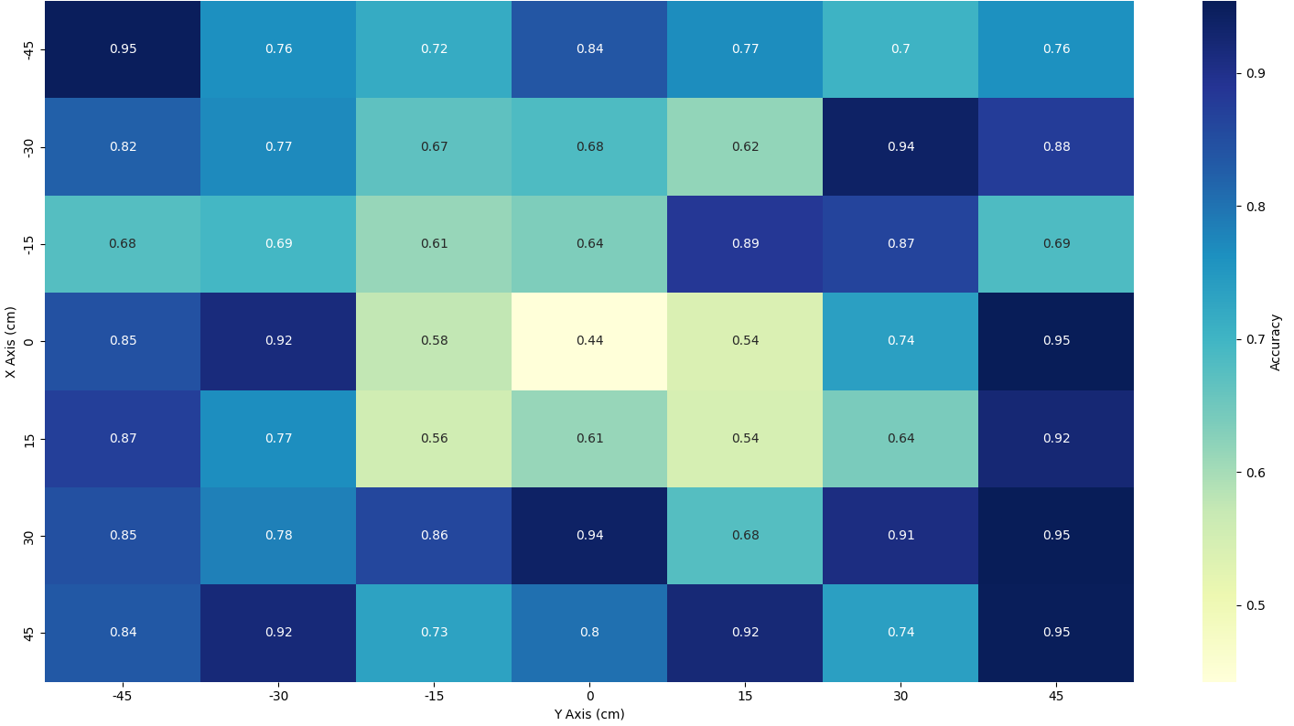
Figure 3: Accuracy Matrix w.r.t Position

Autonomous Navigation and Voice Command Tracking:
For Autonomous systems, especially those relying on directional vocal input for instructions that demand a physical action as output [8], the ability to localize the directional element of sound allows a less computationally heavy task such as computer vision for instance [7]. To evaluate performance in such applications, the CDF (Cumulative Distribution Function) and angular error have been recorded and plotted as seen in Figure 4. This margin of error although significant, still gives enough certainty for inverse kinematic based calculations to reliably predict and orient for movement. Navigation specifically allows the correlation data to approximate errors using a PID based algorithm to feasibly have reliable and predictable movement across multiple axis’s as highlighted in [10].
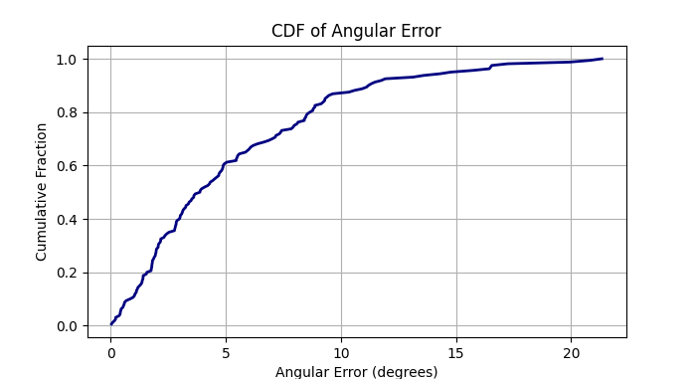
Figure 4: CDF (Cumulative Distribution Function) w.r.t Angular Error

(4) Build Details

Availability of materials and methods

The hardware component of the presented work consists of the PCB and the Components for assembly. The PCB has been designed with a liberal DRC margin (0.1mm) for ease of supply with most manufacturers however it is suggested to work with 1 oz/ft^2 copper and two layers of copper at minimum The components list can be found listed below on Table 2:

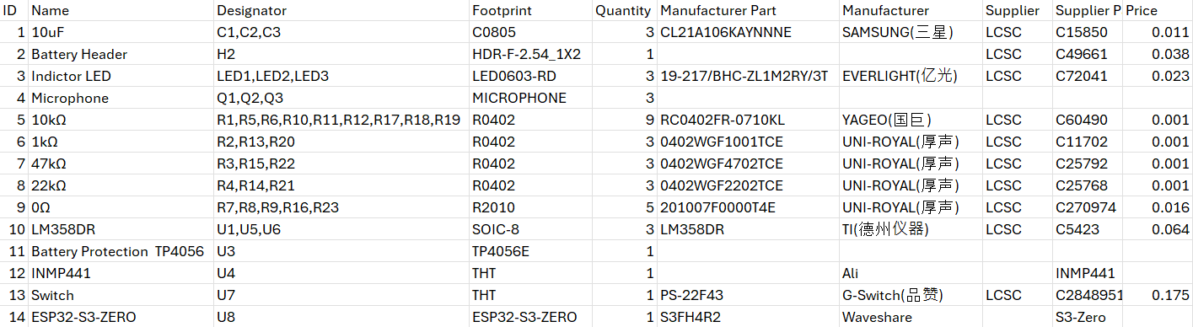
Table 2: Bill of Materials

Other components used such as the TP4056 Battery Protection IC and the Waveshare ESP32-S3-ZERO are easily available across most suppliers/distributors. Passive electrical components are interchangeable within parasitic tolerances of ± 5% for resistors and ± 20% for capacitors. Modifications to the design are encouraged with a special focus on Differential pairs between the circuitry around the Analog pins and power supply lines.

Ease of build / Design decision
Assembly is easily reproducible using the included BOM file for PCB manufacturing and the Pick and Place file for assembly. Additionally individual components were reduced to a reasonable extent to ensure an easier experience while hand soldering.

2 Layer PCB designs using an ESP32 WROOM module were attempted but no to much success due to signal interreference issues with the ground plane. Clustering of Analog preamps are recommended due lower signal bleed across adjacent microphones. For Custom Designs, it is advised to not layer Signal Traces above direct Ground Planes to prevent cross talk.

Operating software and peripherals
The ESP32-S3 Module used runs on standard ESPRESSIF Firmware with its dual-core architecture allowing the assignment of Microphone reading, Signal preprocessing, FIR filtering to Core 1 and The Approximation engine to Core 2. The computation is done through the “MicroDSP” library written in C++ and Wiring developed using the Arduino Core framework for ESP32-S3 by ESPRESSIF built on the ESP-IDF version (5.4.2) along with the ESP32-S3’s I2S audio interface for low latency communication with the ADCs. The combined use of the “MicroDSP” library and devices’s core firmware utilizes around 60-70% of available SRAM (around 364 KB) leaving headroom for implantation for application specific extensions [5]. It is recommended to run all adjacent tasks on FreeRTOS architectures for application-based sequence modifications. The allocations and load distributions along with output parsing is left at the user’s discretion allowing changes in SRAM allotted, as further elaborated on in the MicroDSP documentation. Real time debugging is encouraged through Serial output or Digital Dashboard interfaces through MQTT, HTTP or ESP now for evaluation and data collection to optimize calibration coefficients for calibration.

Dependencies
The software component of the presented work included the Core firmware and the MicroDSP library having been developed using the open-source Arduino Core framework for ESP32 maintained by ESPRESSIF and the Arduino Project. Although not required Python 3.13.3 and libraries including CSV, NumPy and Matplotlib which are opensource maintained by Python software foundation, Team NumPy and MathWorks respectively were used for Data collection, CSV Processing and post-processing. The Hardware component depends on an ESP32-S3 module for processing and the custom designed microphone array based on the LM356DR Operational Amplifier, the hardware is intended to be extensible for application specific components with only 3 of the Primary ADCs used for localization, leaving all other Digital pins, I2C and UART peripherals open. with differing requirement-based applications. Figure 5 and Figure 6 show the schematics for the microphone and compute module respectively.
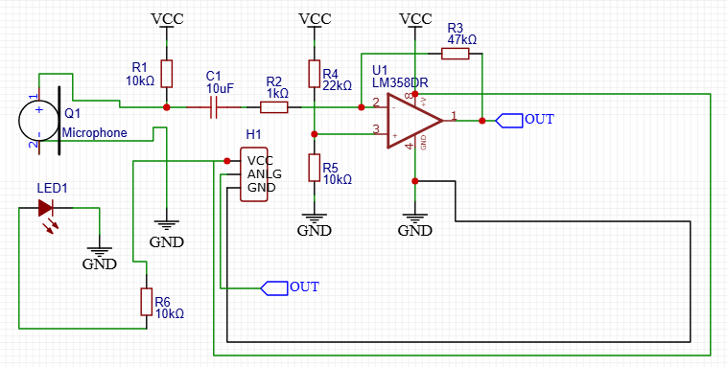

Figure 5: Microphone Schematic

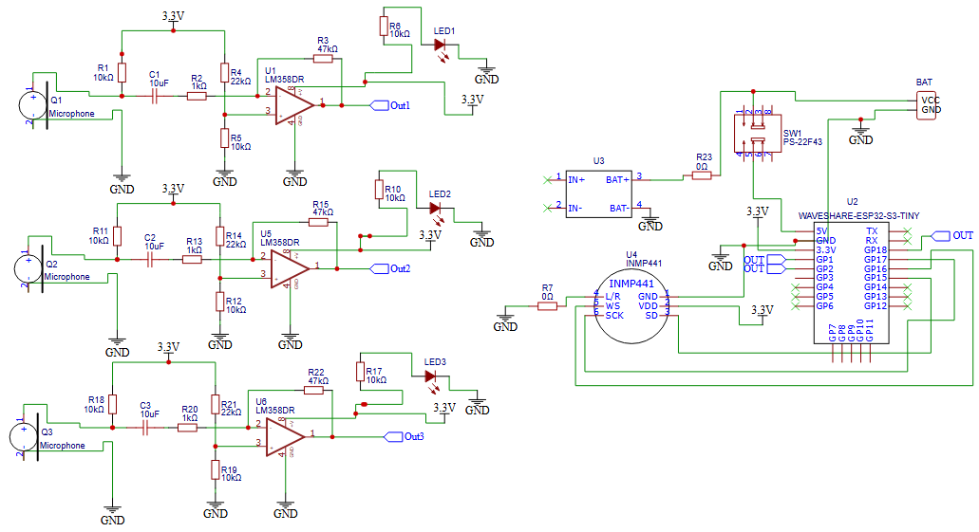
Figure 6: Compute module Schematic with Mic’s attached

Hardware documentation / build instructions / file’s location:
Archive for hardware documentation and build files (required)
Note: We require the inclusion of modifiable design files as well as detailed documentation of the design rationale of the hardware with assembly instructions. This will be assessed as part of the journal peer-review process.
Step-by-step build instructions must be available online in a repository or submitted as supplementary material.

For the assessment of the article, these repositories can be modifiable, for example, on GitHub or GitLab. Once the article has been accepted, these repositories must be moved in a preservation and immutable repository, for example, Zenodo.

Name: Embedded sound localization platform based on the ESP32-S3 and custom microphones
Persistent identifier: https://zenodo.org/records/15420971
Publisher: Chikkala Aneesh Arnav
Date published: 2025-mm-dd

Modifiable design files (if different from above)
Name: SAME AS BUILD INSTRUCTIONS
Persistent identifier: e.g. DOI, handle, PURL, etc.
Publisher: Name of the person who deposited the documentation
Date published: 2025-10-05

Software code repository (e.g. SourceForge, GitHub etc.) (required)
Name: MicroDSP hardware to software integration and Calibration data
Identifier: https://zenodo.org/records/17267875
Date published: 2025-10-05

(5) Discussion

Conclusions
This work demonstrates a practical and resource efficient approach for real time embedded sound localization by comparing a custom microphone array with optimized signal processing and a highly calibrated Hedging algorithm contained in a modular hardware enclosure allowing for various applications ranging from assistive hearing to autonomous robotics. Future efforts will focus on the integration of adaptive filters and power efficient machine learning enhancement to further enhance localization accuracy and system robustness.

Future Work
Three areas of future system development can be targeted for greater results. First, application of adaptive filtering algorithms can improve performance in varying environments by adjusting parameters in real-time [6]. Second, optimization of the localization algorithms with data-driven or machine learning estimation techniques at comparably lower computational expense. Finally, working on expansion of application-based integration making use of the directional component of sound.

Paper author contributions (CRediT)
Chikkala Aneesh Arnav: Methodology, Investigation, PCB Design, PCB Assembly, Writing, Library development, Testing.

Acknowledgments
This work was conducted in part with the guidance and support of Mrs. Pooja Kapur, whose insights on methodology and investigative troubleshooting were essential in pieces of guidance in this work. I also thank Mrs. Swapna Reddy for her continued encouragement and support. I Acknowledge Delhi Public School, Miyapur, for supporting me in perusing this alongside my academic commitments.

Funding statement
This work was self-funded by the author.

Competing interests
The authors have no competing interests to declare.

References
[1] Tashev IJ. Sound capture and processing: practical approaches. John Wiley & Sons; 2009 Jul 1.
[2] Seltzer ML. Microphone array processing for robust speech recognition. Carnegie Mellon University; 2003.
[3] Albataineh Z, Salem F, Ababneh JI. Linear phase FIR low pass filter design using hybrid differential evolution. International Journal of Research in Wireless Systems (IJRWS). 2012 Dec;1(2):43-9.
[4] Roy TK, Morshed M. Performance analysis of low pass FIR filters design using Kaiser, Gaussian and Tukey window function methods. In2013 2nd international conference on advances in electrical engineering (icaee) 2013 Dec 19 (pp. 1-6). IEEE.
[5] Takeshita H, Shimizu S, Ishikawa H, Watanabe A, Arakawa Y, Yamanaka N, Shiba K. Fast optimal replica placement with exhaustive search using dynamically reconfigurable processor. Journal of Computer Networks and Communications. 2011;2011(1):707592.
[6] Zhang Y. Enhancing sound source localisation and music teaching through integrated computational resource allocation. Molecular & Cellular Biomechanics. 2024 Nov 7;21(2):355-.
[7] Tokgöz S, Kovalyov A, Panahi I. Real-time estimation of direction of arrival of speech source using three microphones. In2020 IEEE Workshop on Signal Processing Systems (SiPS) 2020 Oct 20 (pp. 1-5). IEEE.
[8] Scola CF, Ortega MD. Direction of arrival estimation: A two microphones approach.
[9] Frosolini A, Franz L, Caragli V, Genovese E, de Filippis C, Marioni G. Artificial Intelligence in Audiology: A Scoping Review of Current Applications and Future Directions. Sensors (Basel)
[10] Jekateryńczuk, Gabriel, and Zbigniew Piotrowski. “A Survey of Sound Source Localisation and Detection Methods and Their Applications.” Sensors (Basel, Switzerland) vol. 24,1 68. 22 Dec. 2023

(6) Licenses
Article: CC-BY 4.0
Hardware: CERN-OHL-P
Software: MIT

Copyright notice
Authors who publish in this journal agree to the following terms:

Authors retain copyright and grant the journal right of first publication with the work simultaneously licensed under a Creative Commons Attribution License that allows others to share the work with an acknowledgment of the work's authorship and initial publication in this journal.

Authors can enter into separate, additional contractual arrangements for the non-exclusive distribution of the journal's published version of the work (e.g., post it to an institutional repository or publish it in a book), with an acknowledgment of its initial publication in this journal.

By submitting this paper you agree to the terms of this Copyright Notice, which will apply to this submission if and when this journal publishes it.

